[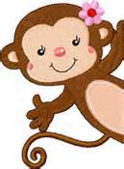](http://www.bing.com/images/search?q=monkey+clipart&qpvt=monkey+clipart&FORM=IGRE&adlt=strict%23view=detail&id=324DAD5DCD05FA05EC35B326BBBC4161F58B2F44&selectedIndex=583)[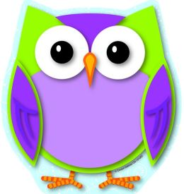](http://www.picturesof.net/pages/090402-178071-019052.html)

4th Grade

**Weekly News**

**January 26th- February 3rd**

**Spelling**

|  |  |  |  |
| --- | --- | --- | --- |
| **1.** |  | tasted |  |
| **2.** |  | ripping |  |
| **3.** |  | forced |  |
| **4.** |  | flipping |  |
| **5.** |  | tapped |  |
| **6.** |  | flipped |  |
| **7.** |  | scared |  |
| **8.** |  | flagged |  |
| **9.** |  | ripped |  |
| **10.** |  | skipped |  |
| **11.** |  | tapping |  |
| **12.** |  | saved |  |
| **13.** |  | skipping |  |
| **14.** |  | scaring |  |
| **15.** |  | flagging |  |
| **16.** |  | discussed |  |
| **17.** |  | saving |  |
| **18.** |  | tasting |  |
| **19.** |  | forcing |  |
| **20.** |  | discussing |  |

**Important Dates**

**-2/1/17-Language and Spelling Test**

**-2/3/17- Reading Test**

**Weekly Homework**

**\*\*Please make sure students turn in homework daily.**

**Reading**

Read 20 Minutes Each Night

READ READ READ!!!! ☺

Spelling

**Thursday-** Sentences/STUDY

**Friday-** STUDY

**Monday**- ABC Order /STUDY

**Tuesday-** Ladder Writing /STUDY

**Wednesday-** TEST

**Thursday-**NONE

**Friday**-NONE

Math

Thursday: DP pg. 383 & HW pg. 384

Friday: DP pg. 385 & HW pg. 386

Monday: DP pg. 390 & HW pg. 391

Tuesday: DP pg. 394

Wednesday: DP pg. 397 & HW pg. 398

Thursday: DP pg. 401 & HW pg. 403-404

Friday: DP pg. 407 & HW pg. 408

^

**Weekly Skill Focus**

**Reading**:

**Essential Question**:

“Why do we need Government?”

**Skills and Strategies:**

Cause and Effect, Answering and Asking Questions, and Latin Roots.

***Genre:*** Narrative Nonfiction

**Language:** Identify types of pronouns

**Math**: Comparing Fractions and Adding/Subtracting Fractions

**Science:** The Sun Our Star

**Social Studies:** Chapter 8; The Great Depression

[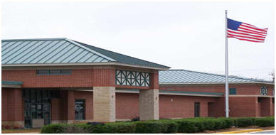](http://www.google.com/url?sa=i&rct=j&q=&esrc=s&frm=1&source=images&cd=&cad=rja&docid=rZqBVa-hf4T96M&tbnid=xUt-ukKcXeKljM:&ved=0CAUQjRw&url=http://www.myxer.com/wallpaper/id/3322960/soulpatrolmn/Cute-Owl/&ei=hOwoUpDGGYi08QT9kIHQCA&bvm=bv.51773540,d.eWU&psig=AFQjCNGBNcLP0xq3pRwGv9les6OjgNv3-Q&ust=1378500088373572)

**Vocabulary**

|  |  |
| --- | --- |
| **amendments-** | **Amendments** are formal changes made according to official procedures. |
| **commitment-** | A **commitment** is a sense of obligation toward something. |
| **compromise-** | To **compromise** means to reach agreement by having each side give up part of its demands. |
| **eventually-** | **Eventually** means in the end or finally. |
| **legislation-** | **Legislation** means laws that are made or passed. |
| **privilege-** | A **privilege** is a special right or benefit held by a certain group of people. |
| **version-** | A **version** is an account given in a particular way. |

democracy- A **democracy** is a government that is run by the people who live under it.